Aaron Steele atsteele@ucsc.edu

Tommy Tran ttran56@ucsc.edu

**Problem 1: Support Vector Machines**

This simple data set is linearly separable, because we can see the distance between the support-vectors are basically one where wx +b = 0. The points of the support vectors are (0,4), (2,1), (2,4), and (4,2).

Where wx + b = 0

* 1. The size is 4.
  2. The margin would increase or just stay the same, because the support vectors are the ones holding the margin from expanding. For example, if we were given just three points, (-1,-1), (1,1), (3,1), then as of now, the margin is 2, but if we remove (1,1), then now, it’s a margin size of 4.
  3. It would decrease because the geometric margin depends on the support vectors.
  4. Well, the slack variable value should be at zero then if the point is correctly classified, because the slack variable is only needed if the point is not classified, and would therefore need an error margin.
  5. Say the # of mistakes is 0, then we have 0 ≤ $\sum_{i}{ἐ_{i}}$

Then we have

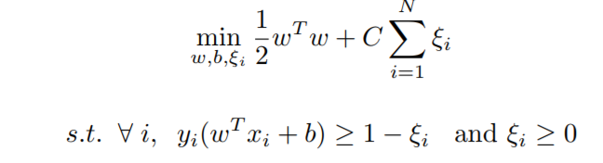

Where the entire right side becomes 0, so we only have

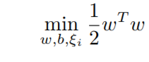

Which is just the geometric margin with the points where it was correctly classified and support vectors.

* 1. Where C1 < C2, we would expect the model if the C2 value to have more mistakes on the training set. The c parameter is the loss function’s multiplier, so the bigger the c, the more errors you have and are penalized.
  2. Yes, because soft margin still includes the hard margin as a special case. Though the hard margin case, it does not allow any errors, and would therefore be hard to just achieve that model in real life. With soft margin, we can still have errors, but be able to fit the model to the training data set. Also, the higher the C, the more the svm will be sensitive to noise, because the higher the c, the more we are penalize for making errors.